UNIT 12 HW
Spring 2025 /
Just do Question 1 and Review the Solution to Question 2
- As part of a study of the effects of predatory intertidal crab species on snail populations, researchers measured the mean closing forces and the propodus heights of the claws on several crabs of three species. The crab data will be in your files repository.
- Use alpha = 0.05, where necessary.
- Use SAS or R and provide relevant code and output.
- Step 1: Use the code from Dr. McGee’s lecture to plot a scatter plot of claw closing force (response variable) versus propodus height (explanatory variable), with different plotting symbols (or colors) to distinguish the three different crab species. Judging from an initial visual assessment of the scatterplots, you may apply a transformation and replot in this step. If a transformation is necessary, you only need to provide the scatterplot for the most visually satisfying transformation for now (but still provide a scatterplot of original data). You will formally assess the fit of the model in Step 4.
  - See below for Screen Caps
  - Code:
proc sgplot data=WORK.crab_force;
scatter x=Height y=Force / group=Species markerattrs=(symbol=CircleFilled size=10);
run;

ods graphics on;

proc glm data=WORK.crab_force plots=all;
class Species;
model Force = Height|Species;
run;
ods graphics off;

proc sgplot data=WORK.CRAB_FORCE;
scatter x=log_Height y=log_Force/ group=Species markerattrs=(symbol=CircleFilled size=10);
run;

ods graphics on;

proc glm data=WORK.crab_force plots=all;
class Species;
model log_Force = log_Height|Species;
run;
ods graphics off;
- Step 2: Build a model. (Simply write an appropriate equation as was shown in class.) This model should allow for separate fits (separate lines) for each crab species and should also allow for each line to have its own slope. Use lopho crab as the reference. (This is the default if the data is in alphabetical order.)

Parameter | Estimate |  | Standard  Error | t Value | Pr > |t|
Intercept | -3.780025514 | B | 1.15560007 | -3.27 | 0.0026
log_Height | 2.973651348 | B | 0.55113983 | 5.40 | <.0001
Species Cancer productus | 1.812752064 | B | 1.85332936 | 0.98 | 0.3354
Species Hemigrapsus nudus | 4.299169517 | B | 1.52825142 | 2.81 | 0.0083
Species Lophopanopeus bellus | 0.000000000 | B | . | . | .
log_Height*Species Cancer productus | -0.905200323 | B | 0.83015267 | -1.09 | 0.2837
log_Height*Species Hemigrapsus nudus | -2.565338521 | B | 0.73537591 | -3.49 | 0.0014
log_Height*Species Lophopanopeus bellus | 0.000000000 | B | . | . | .
  - Ln = Natural Log REF= Lophopanopeus Bellu
    - Lopho Crab: ln(Force)= -3.78 + 2.97(ln(Height)) +
    - Cancer Crab: ln(Force) = (-3.78 + 1.81)+(2.973 – 0.90)ln(Height)
    - Hemigr Crab: ln(Force) = (-3.78+ 4.299) + (2.973 -2.56)ln(Height)
- Step 3: Fit the model. (Fill in the relevant betas in your equation for step 2.) Make sure you provide relevant code and the table of parameter estimates as well.
  - Table Shown Above ^^^
    - Code:
proc glm data=WORK.crab_force;
class Species;
model log_Force = log_Height|Species / solution;
run;
quit0;
- Step 4: Provide a residual plot, studentized residual plot, histogram of residuals, and q-q plot of residuals to provide evidence of the appropriateness of the model. Provide a short one- or two-sentence discussion of EACH plot.
  - Plot Provided Below
  - Residual Plot: The residual points are random throughout the whole plot, there may be some crowding towards the right-end of the plot, but compared to the residual plot this Post transformation residual plot, is a lot more randomized
  - Studentized R Plot: There seems to be 2 points that are outside of the (-2 ↔ 2) range. There does not seem to be any clear pattern, the distribution of the plot seems to fit a random normal distribution
  - Residual Histogram: There is a VERY small right skew, but overall the residual distribution follows a bell-shaped distribution, indicating a normal distirbution.
  - QQ Plot: The QQ Plot points, follow the line VERY closely, suggesting that the data provided follows a normal distribution.
- Step 5: If the fit assessed in Step 4 is sufficient, interpret each coefficient in the model.
  - Intercept(B0):-3.78
    - If the Height of a crab was at 0, the Force would be -3.78. Since this is neither possible to have negative force nor have a “alive” crab at height measurement of 0. The intercept is a theoretical value for a “0” height crab
  - log_height(B1)
    - Every One-Unit increase to X, increase the mean log(force) by an average of 2.97
  - Species Cancer Productus
    - This is an adjustment to the intercept which is using the Lopho Crab as a reference. If we are measuring a Cancer Crab, than we would add 1.81 to the intercept, which would make the intercept -1.97 for the Cancer Crab.
  - Species Hemigrapsus nudus
    - This is an adjustment to the intercept which is using the Lopho Crab as a reference. If we are measuring a Hemigrap Crab, than we would add 4.3 to the intercept, which would make the intercept 0.52 for the Hemigrap Crab.
  - log_height*Species Cancer productus
    - This is an adjustment to the slope, When we are measuring the Cancer crab, we would subtract 0.9052 from B1. This value would be 2.068451025
  - log_height*Species Hemigrapsus nudus
    - This is an adjustment to the slope, when we are meausuring the Hemigrap crab, we would subtract 2.57 from B1, which would make the slope for the Hemigrap crab 0.408

- Provide three individual regression equations (one for each crab species).
  - Lopho Crab: ln(Force)= -3.78 + 2.97(ln(Height)) +
  - Cancer Crab: ln(Force) = (-3.78 + 1.81)+(2.973 – 0.90)ln(Height)
  - Hemigr Crab: ln(Force) = (-3.78+ 4.299) + (2.973 -2.56)ln(Height)
- How many degrees of freedom were used to estimate the error term (MSE) in question 1?
What is the estimate of the MSE?
  - Question 1 was answering a ScatterPlot???
but , I believe the MSE for the error would be 32

Source | DF | Sum of Squares | Mean Square | F Value | Pr > F
Model | 5 | 2350.597765 | 470.119553 | 23.79 | <.0001
Error | 32 | 632.347762 | 19.760868
Corrected Total | 37 | 2982.945526

Answers:
1a) I logged the data.

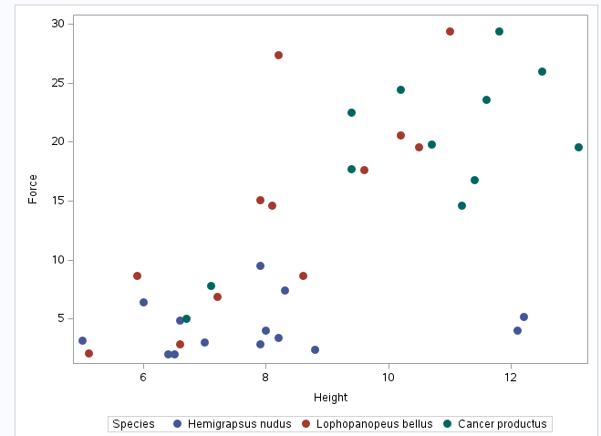

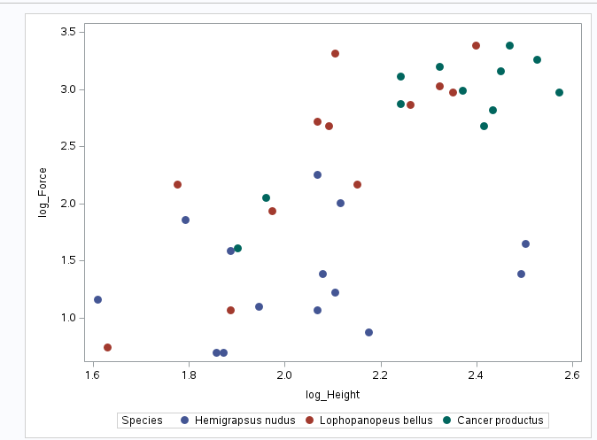

1d)

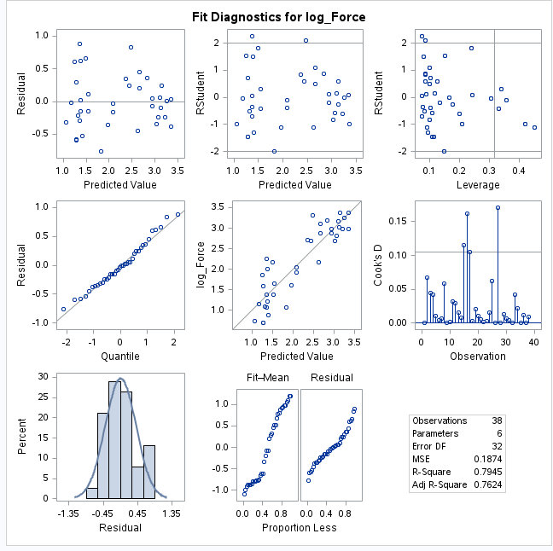

- Read the introduction to the Mammal Brain Weight data that starts on page 239 (Section 9.1.2). Download the Brain data set from 2DS. We would like to see if gestation length and litter size are associated with brain weight after controlling for different body sizes. That is, we already know that brain size is related to body weight; therefore, we don’t want body size to be a confounding variable. We would like to measure the association of the other variables after taking into account the body size.

Answer this question by performing an analysis by following the 5 steps laid out in the problem above. Remember in step 2 to only include the terms that will help you answer this question of interest (QOI).
- Use alpha = 0.05, where necessary.
- Use R and provide relevant code and output.

Question 2 Solution
Read the introduction to the Mammal Brain Weight data that starts on page 239 (Section 9.1.2). Download the Brain data set from Canvas. We would like to see if gestation length and litter size are associated with brain weight after controlling for different body sizes. That is, we already know that brain size is related to body weight; therefore, we don’t want body size to be a confounding variable. We would like to measure the association of the other variables after taking into account the body size.
Answer this question by performing an analysis by following the 5 steps laid out in the problem above. Remember in step 2 to only include the terms that will help you answer this question of interest (QOI).
- Use alpha = 0.05, where necessary.
- Use R and provide relevant code and output.
(8 points) Step 1: Scatterplots
Original data:

brain <- read.csv("C:/Users/Charles/Documents/SMU/Online Teaching/MSDS 6371 - Statistical Foundations for Data Science/UNIT 12/Brain.csv")
pairs (~ Brain + Body + Gestation + Litter, data = brain)
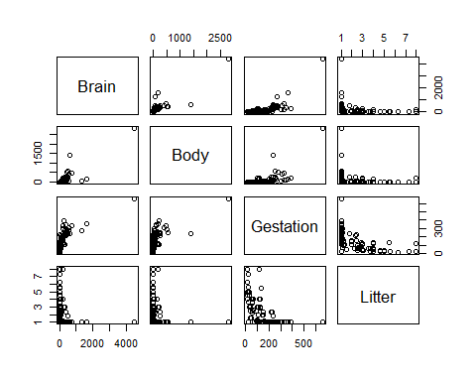
Try a transformation with every relevant variable logged.
lbrain <- log(brain$Brain)
lbody <- log(brain$Body)
lgestation <- log(brain$Gestation)
llitter <- log(brain$Litter)
pairs(~ lbrain + lbody + lgestation + llitter, data = brain)
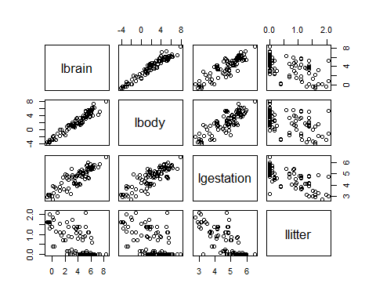
The log transformed variables look to visually satisfy assumptions of linear trend, constant variance and conditional normality. Independence will be assumed.

(6 points) Step 2: Build a model

(10 points) Step 3: Fit the model

brain.lm <- lm(lbrain ~ lbody + lgestation + llitter, data = brain)
summary(brain.lm)
##
## Call:
## lm(formula = lbrain ~ lbody + lgestation + llitter, data = brain)
##
## Residuals:
## Min 1Q Median 3Q Max
## -0.95415 -0.29639 -0.03105 0.28111 1.57491
##
## Coefficients:
## Estimate Std. Error t value Pr(>|t|)
## (Intercept) 0.85482 0.66167 1.292 0.19962
## lbody 0.57507 0.03259 17.647 < 2e-16 ***
## lgestation 0.41794 0.14078 2.969 0.00381 **
## llitter -0.31007 0.11593 -2.675 0.00885 **
## ---
## Signif. codes: 0 '***' 0.001 '**' 0.01 '*' 0.05 '.' 0.1 ' ' 1
##
## Residual standard error: 0.4748 on 92 degrees of freedom
## Multiple R-squared: 0.9537, Adjusted R-squared: 0.9522
## F-statistic: 631.6 on 3 and 92 DF, p-value: < 2.2e-16

(8 points) Step 4: Provide a residual plot, studentized residual plot, histogram of residuals, and q-q plot of residuals to provide evidence of the appropriateness of the model.

##Three of the graphs can be obtained by simply
##plotting the model fit
par(mfrow=c(2,2))
plot(brain.lm, which=c(1:3))
##Histogram with normal curve
##Store studentized residuals
studresbrain <- rstudent(brain.lm)
##Histogram
hist(studresbrain, freq=FALSE, main="Distribution of Studentized Residuals",
xlab="Studentized Residuals", ylab="Density", ylim=c(0,0.5))
##Create range of x-values for normal curve
xfit2 <- seq(min(studresbrain)-1, max(studresbrain)+1, length=40)
##Generate values from the normal distribution at the specified values
yfit2 <- (dnorm(xfit2))
##Add the normal curve
lines(xfit2, yfit2, ylim=c(0,0.5))
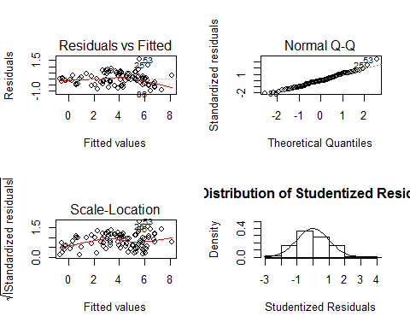
(2 points) Residual Plot: The residual plot resembles somewhat of a random scatter of points around the 0 line although there is a slight suspicion of non-constant variance, as we see a slight funnel shape as the predicted value increases. This is not too serious, and we will proceed with caution.
(2 points) Studentized Residual Plot: This plot is very similar to the Residual plot although this plot identifies potential outlying observations. This plot identifies two potentially very outlying points with a predicted value of around 6. This may provide some evidence against the normality assumption. Further analysis may be necessary on these points.
(2 points) Q-Q Plot of Residuals: The QQ Plot of residuals displayed below provides little evidence that the residuals are not normally distributed.
(2 points) Histogram of Residuals: The histogram of residuals displayed does not provide strong evidence that the residuals are not normally distributed.
(9 points) Step 5: Interpretation
Given that the model looks to fit (given the analysis in Step 4), we now move to interpret the parameter estimates found in Step 3. Both log gestation and log litter were found to be significant when log body was included in the model. This indicates that each doubling of the gestation period, holding all other variables constant, results in a multiplicative change in the median of the brain size. That translates to a 34% increase in the median of the brain size with every doubling of gestation period, holding the weight and litter size constant. In addition, holding all other variables constant, a doubling of the litter size is associated with a multiplicative decrease in the median of brain size. That equates to a 19% decrease in the median of brain size when the

